1.SELECT QUERIES 101:

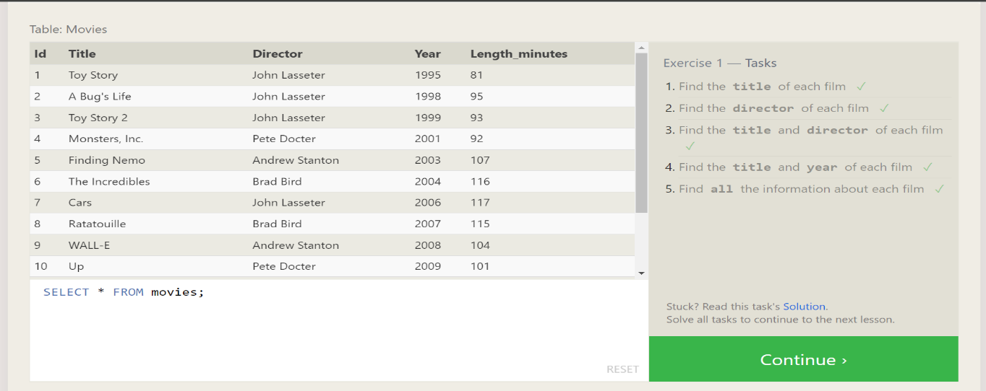

2.QUERIES WITH CONSTRAINTS(PT.1):

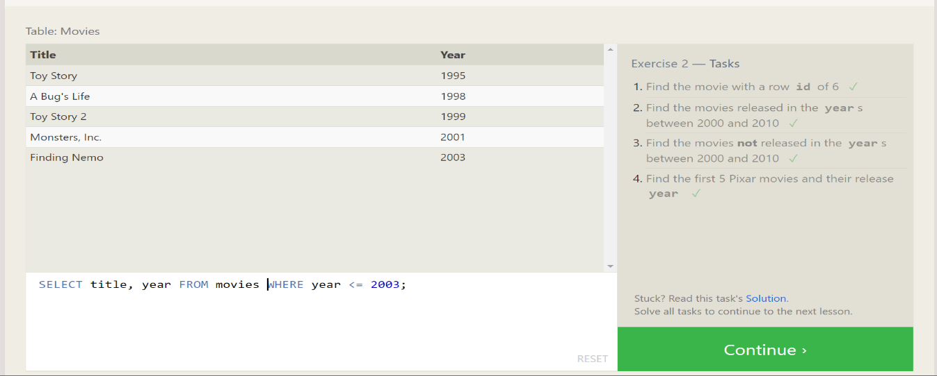

3.QUERIES WITH CONSTRAINTS(PT.2):

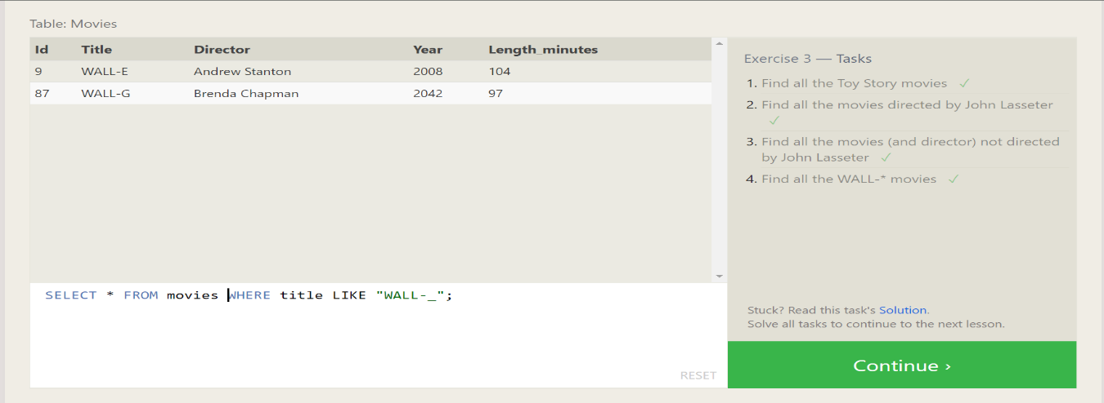

4.FILTERING AND SORTING QUERIE RESULT:

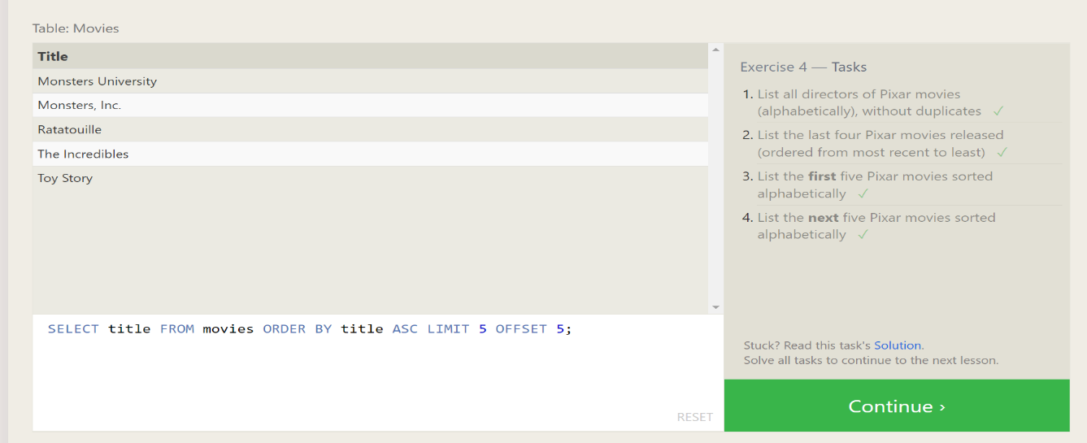

5.REVIEW: SIMPLE SELECT QUERIES:

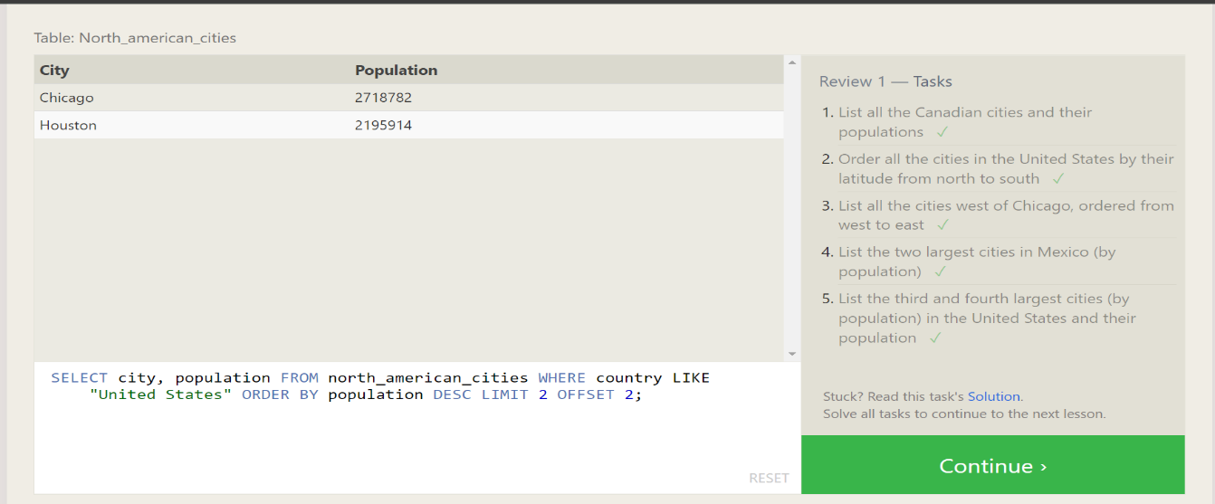

6.MULTI TABLE QUERIES WITH JOINS:

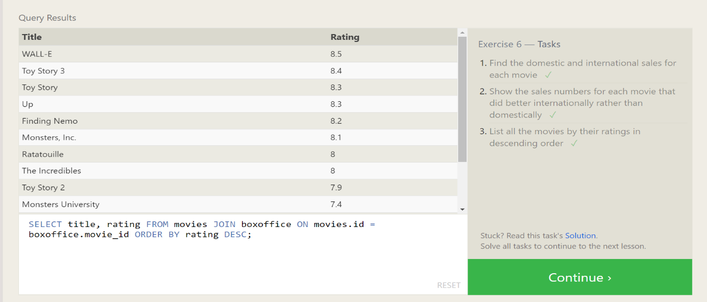

7.OUTER JOINS:

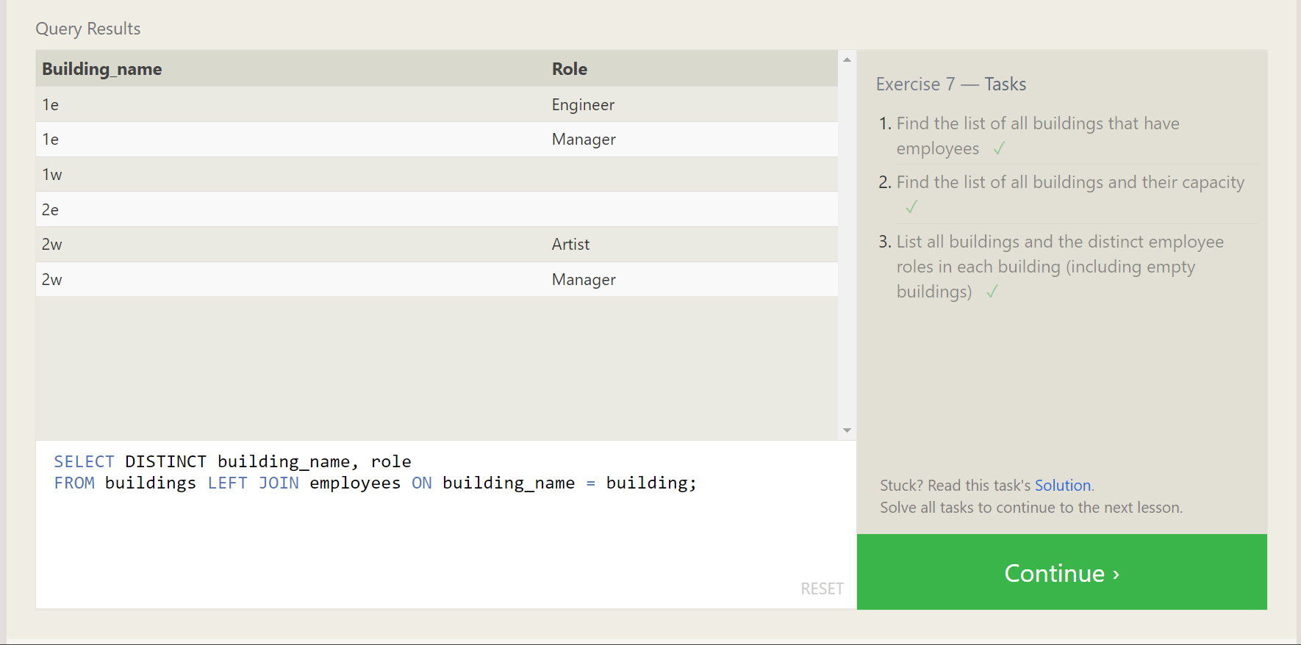

8.A SHORT NOTE ON NULLS:

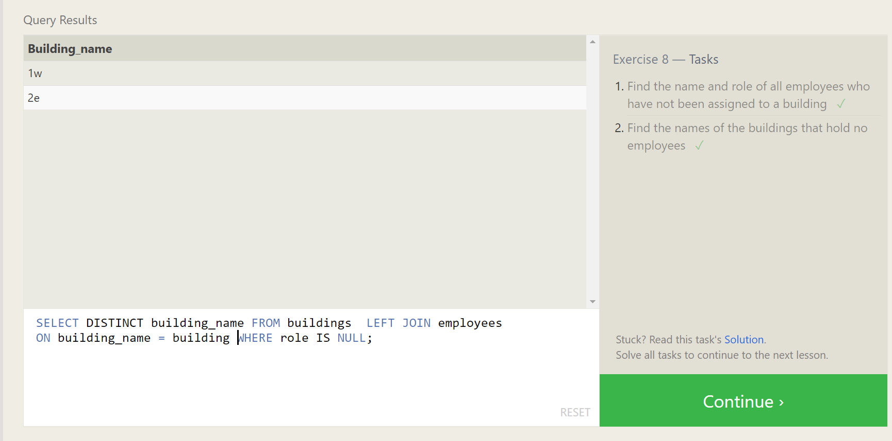

9.QUERIES WITH EXPRESSIONS:

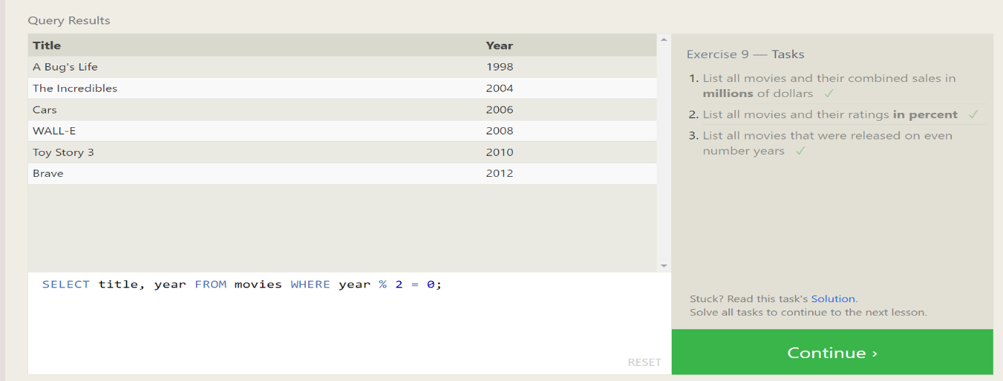

10.QUERIES WITH AGGREGATES(PT.1):

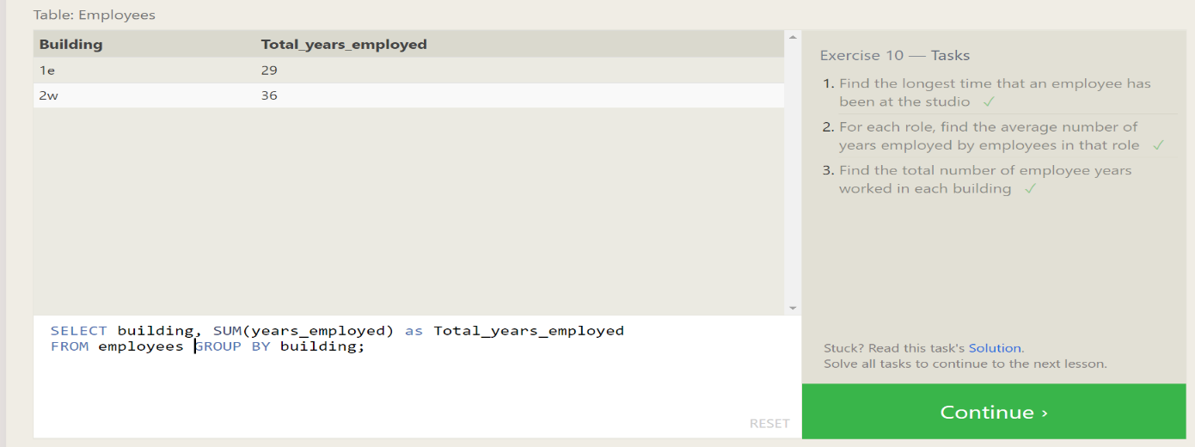

11. QUERIES WITH AGGREGATES(PT.2):

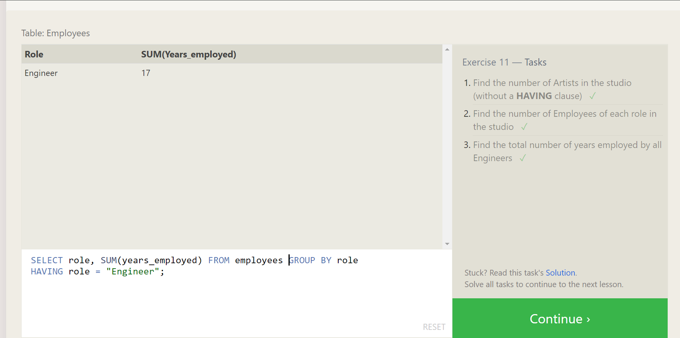

12.ORDER OF EXECUTEION OF A QUERIES:

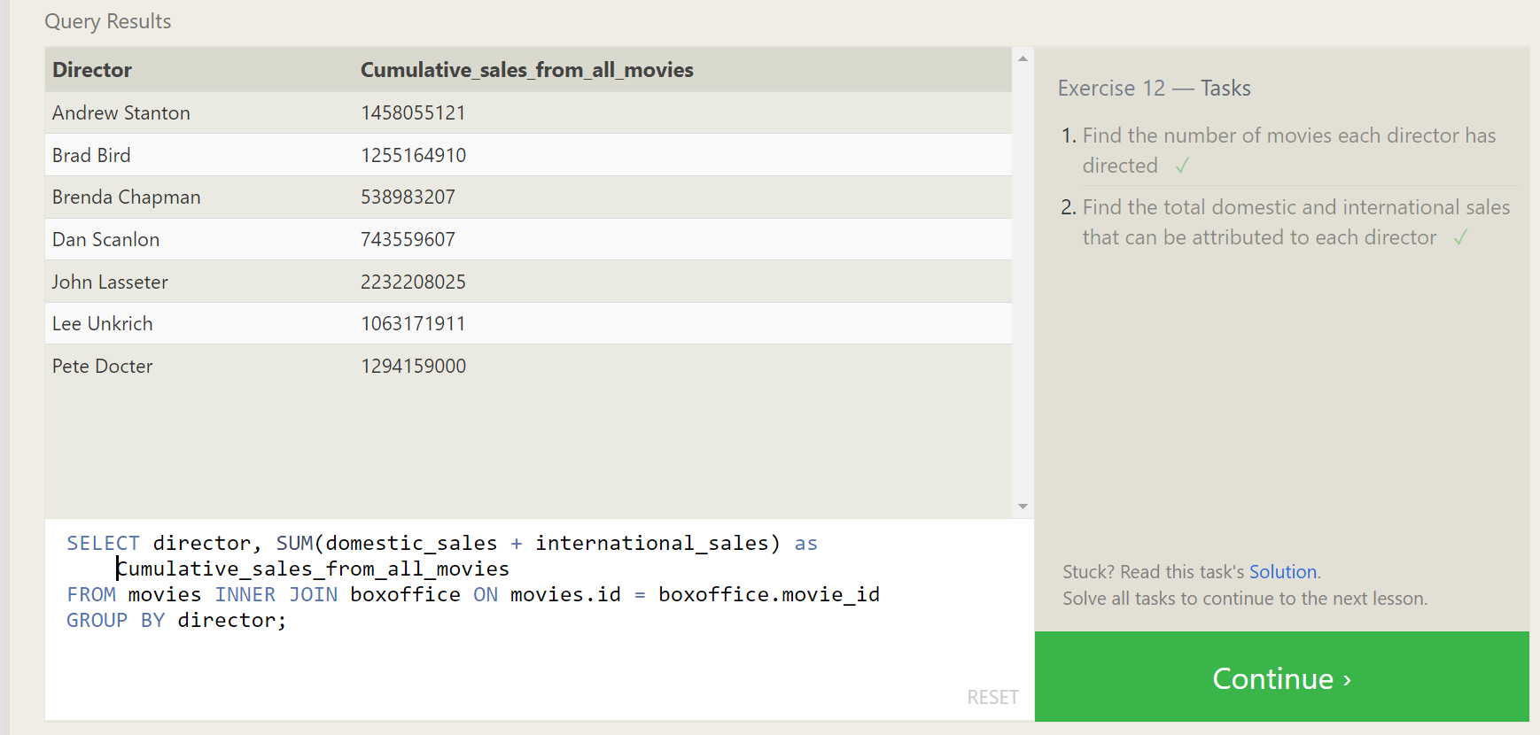

13.INSERTING ROWS QUERY:

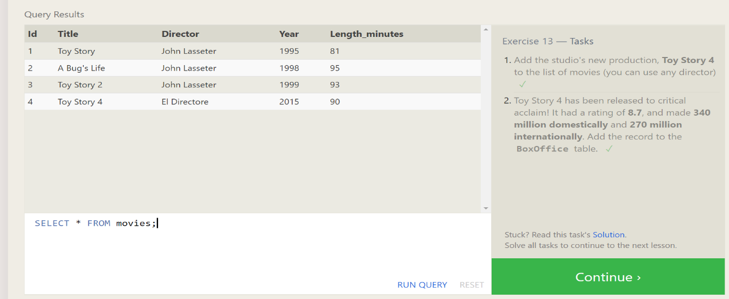

14.UPDATING QUERIES:

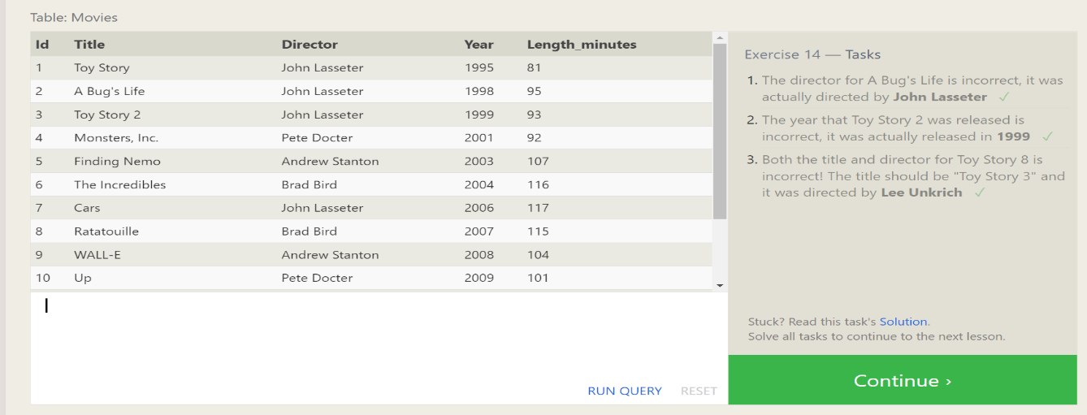

15.DELETING QUERIES:

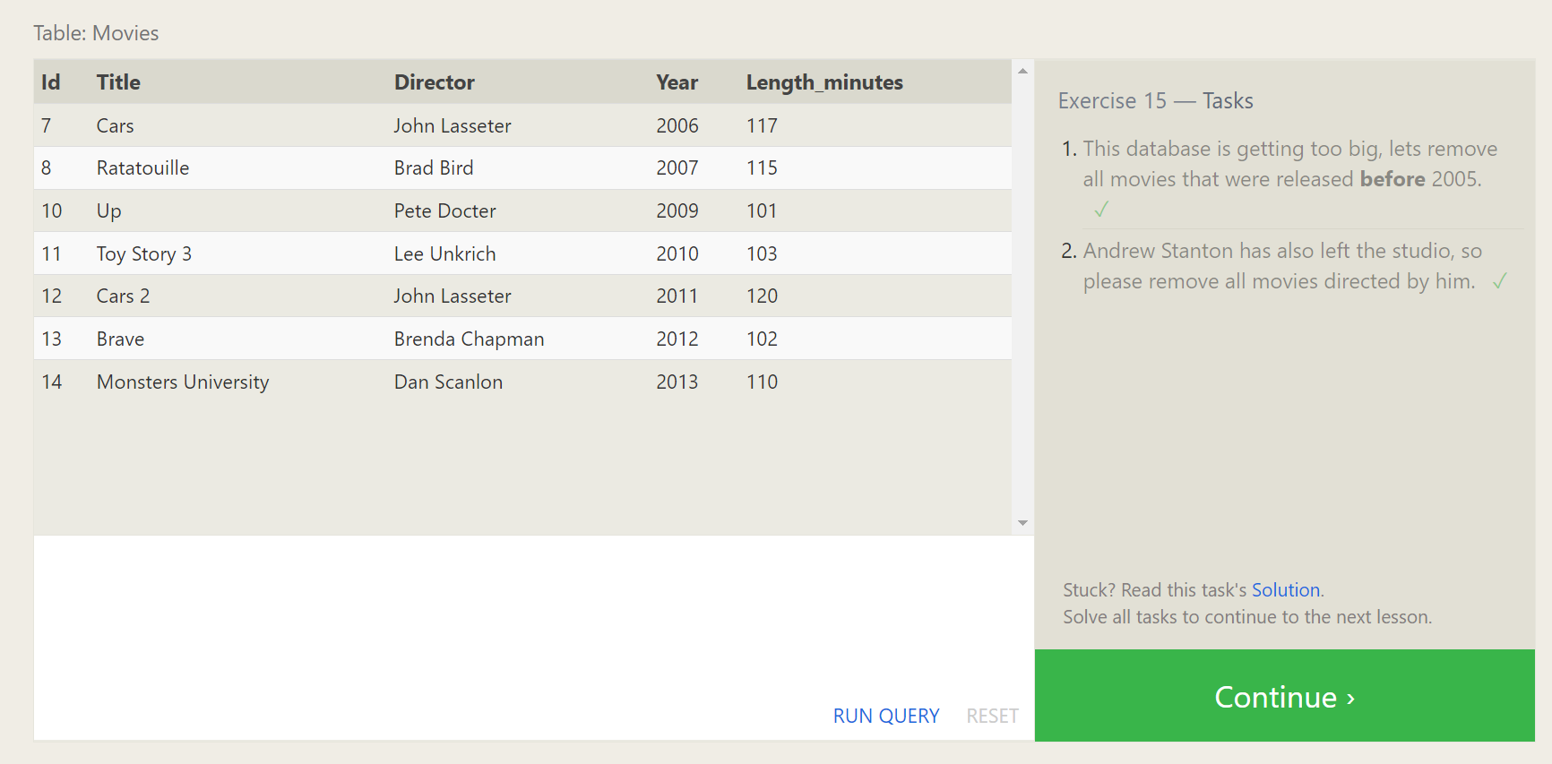

16.CREATING TABLES:

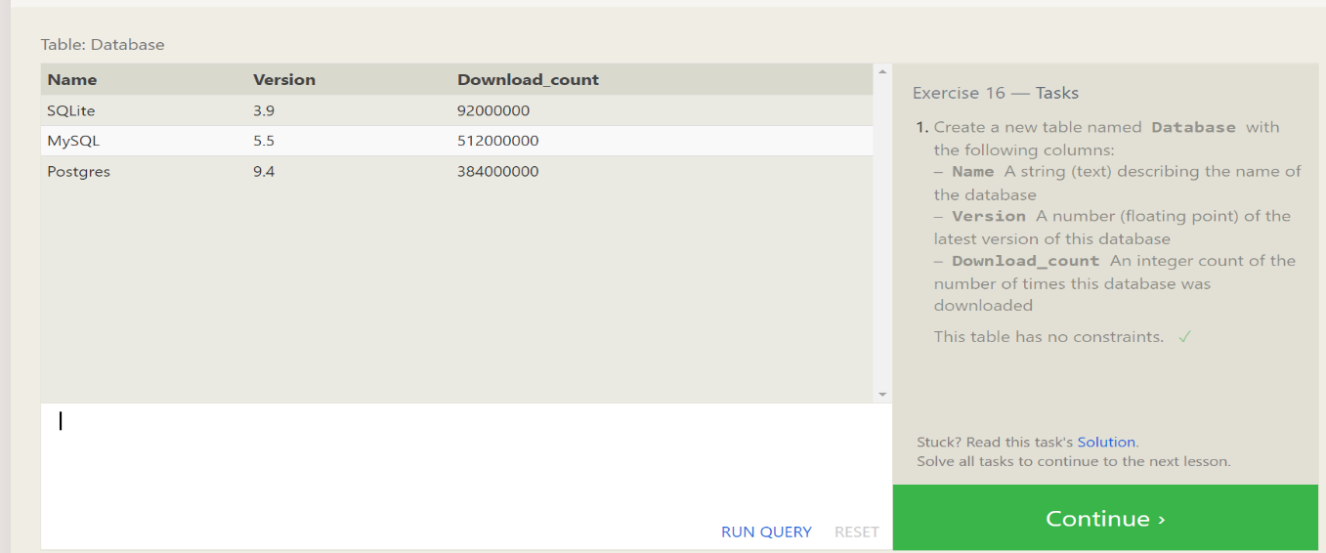

17.ALTERING TABLES:

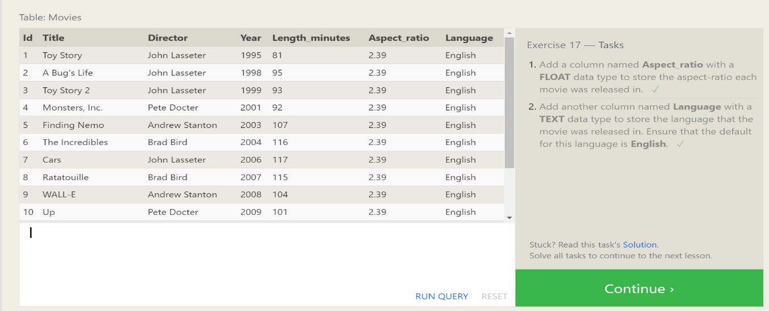

18.DROPPING TABLES:

